Post Details | Last Updated: September 2025
Faculty/Administrative/Service Department | Chief Student Officer Directorate
Job Title | Employer Engagement Officer
Job Family | Professional Services | Job Level | 3
Responsible to | Student Employability Manager
Responsible for (Staff) | n/a
Job Purpose Statement
The post holder will be responsible for supporting the delivery of the Employability and Careers Team strategic aim of maintaining and enhancing the reputation of the University amongst employers. The role focuses on facilitating contact between students and employers in a range of ways, and marketing the activities of the Employability and Careers Team to ensure maximum student participation in a wide range of employer engagement activities and employer-related events, e.g. Careers Fairs and the wide range of events held by the Employability and Careers Team to offer students insights into the world of work and enhance their employability skills.
The ultimate aim of this post is to increase the employability of Surrey Graduates.
Key Responsibilities This document is not designed to be a list of all tasks undertaken but an outline record of the main responsibilities (5 to 8 maximum)
- Organise and host a range of employer led events on campus and virtually, including but not limited to careers networking events, employability skills workshops and other employer visits which are part of the Autumn and Spring events programmes in line with the Employability and Careers Strategy. This will involve a wide range of practical and logistical responsibilities such as managing student sign-ups, evaluating events and reporting and disseminating information provided by speakers.
- Project manage our Autumn Careers & Placements Fair for the team. This is our flagship & largest event for employability in the University.
- Proactively engage with employers and keep up-to-date with market trends regarding employer engagement in higher education, understanding employer recruitment needs and providing insights to the Employer Engagement Manager accordingly to inform the development of employer-related activity.
- Proactively develop relationships with employers to support an account management model of employer engagement with key partners, managing the relationship on behalf of the department to increase the employability prospects of University of Surrey students.
- Assist the Employer Engagement Manager and other colleagues in the Employability and careers as necessary in order to ensure the smooth running of events and activities and the efficient delivery of a high quality service to users.
- Ensure students, employers and colleagues in the Employability and Careers Team and across the university are kept informed of all the events organised by the Employer Engagement team, including the production of necessary promotional materials, supporting social media marketing and updates on the website.
- Support the successful delivery of the Autumn and Spring term employer led events calendar, including all careers fairs and employer led events offering.
- To attend regular team meetings and contribute to initiatives across other parts of the Employability and Careers Team and maintain links with stakeholders internal to the University, e.g. academic staff, the Advancement team, the Marketing Department, the Students’ Union and other relevant stakeholders.

N.B. The above list is not exhaustive. The post holder will from time to time be required to undertake other duties of a similar nature as reasonably required by their line manager.
All staff are expected to:
- Positively support equality of opportunity and equity of treatment to colleagues and students in accordance with the University of Surrey Equal Opportunities Policy.
- Work to achieve the aims of our Environmental Policy and promote awareness to colleagues and students.
- Follow University/departmental policies and working practices in ensuring that no breaches of information security result from their actions.
- Ensure they are aware of and abide by all relevant University Regulations and Policies relevant to the role.
- Undertake such other duties within the scope of the post as may be requested by your manager.
- Work supportively with colleagues, operating in a collegiate manner at all times.
Help maintain a safe working environment by:
- Attending training in Health and Safety requirements as necessary, both on appointment and as changes in duties and techniques demand.
- Following local codes of safe working practices and the University of Surrey Health and Safety Policy.
Elements of the Role
Planning and Organising
- The post holder will operate with minimal day-to-day supervision and in a pro-active and flexible manner; planning and prioritising their workload accordingly.
- The post holder will have to make judgements and re-prioritise their work when faced with conflicting demands. The post holder will also support their line manager, organising activities that contribute to the achievement of the overall objectives of this part of the Employability and Careers service. This will involve delivering an annual Employer Engagement operational plan that fits within the overall Employability and Careers strategy.
- The post holder is expected to raise student awareness and participation in the events programme and the careers fairs. The post holder will be involved in developing the appropriate communication channels for employers and students. They will work with colleagues across the Employability and Careers team with regards to marketing employer events and social media.

Problem Solving and Decision Making
- The post holder is expected to use his or her own initiative and have a significant degree of autonomy. When dealing with routine situations and problems, the post holder is expected to apply appropriate internal policies and their acquired knowledge and judgement to resolve.
- The post holder is expected to use initiative and judgement to address and resolve more complicated problems and refer more complex problems or those issues outside of the remit of their role to their line manager.
- Working in a small team the post holder will be involved in day-to-day queries and enquiries from employers by email, phone and face-to-face, and advising and responding to them appropriately. It will also involve resolution of student queries in relation to employers and events. It will be important to be adaptable in the way that you operate.

Continuous Improvement
- The post holder will be required to apply their comprehensive knowledge gained through substantial experience to progress the University’s objectives in respect of employability, and where relevant, also support the University’s objectives with regard to enterprise skills and entrepreneurship development among students.
- The post-holder is expected to continually look for areas where improvement can be made to the aspects of the service they are involved in. Where the post holder identifies an area of improvement, they are expected to develop solutions and consult with senior team members before implementing the agreed solution.

Accountability
- The post holder should understand the importance of employer engagement to the success of the Employability and Careers service and in particular to the activities undertaken by the Employer Engagement team to support student employability. Failure to successfully manage our interactions with employers could result in lower student engagement, fewer employer events and impact on the reputation of the University with our employer partners.
- Errors in managing relationships, poor project management and difficulties in managing highly demanding workloads have the potential to impact on financial and reputational issues for the University. The post holder is required to have knowledge of stakeholder relationship management, events and project management, student engagement and customer relations and will operate within the policies and practices of the team and any operational guidelines set by their line manager.
Dimensions of the role
- The post impacts across all academic departments as all students have access to the Employability and Careers Team. The post has impact on the graduate employability outcomes of Surrey students.
- The post impacts on the numbers of students engaging in employer-related events, including those who choose to go on a Professional Training placement every year (approximately 1,000) and those choosing not to do a placement year.
Supplementary Information
- The post exists because the University needs a highly effective Employability and Careers Team. Considerable importance is attached to the role played by the team in maintaining the University’s excellent graduate employment record.
Person Specification This section describes the sum total of knowledge, experience & competence required by the post holder that is necessary for standard acceptable performance in carrying out this role.
Qualifications and Professional Memberships |  |  |  | Essential/ Desirable
HNC, A level, NVQ 3, HND level or equivalent with a number of years' relevant experience.  Or:  Broad vocational experience, acquired through a combination of job-related vocational training and considerable on-the-job experience, demonstrating development through involvement in a series of progressively more demanding relevant work/roles. |  |  |  | E
Technical Competencies (Experience and Knowledge) |  |  | Essential/ Desirable | Level  1-3
A proactive approach, with the ability to use initiative in dealing with issues as well as a flexible approach to work, able to multi-task, satisfying the needs to different groups |  |  | E | 3
Experience with multi-channel communications tools for stakeholder management. |  |  | E | 2
Experience and knowledge of the graduate recruitment market |  |  | E | 2
Special Requirements: |  |  |  | Essential/  Desirable
Some weekend/evening work may be required as directed by your line manager |  |  |  | E
Annual leave may be restricted at key times during the year. |  |  |  | E
Core Competencies This section contains the level of competency required to carry out this role. (Please refer to the competency framework for clarification where needed). n/a (not applicable) should be placed, where the competency is not a requirement of the grade. |  |  |  | Level  1-3
Communication  Adaptability / Flexibility  Customer/Client service and support  Planning and Organising  Continuous Improvement  Problem Solving and Decision Making Skills  Managing and Developing Performance  Creative and Analytical Thinking  Influencing, Persuasion and Negotiation Skills  Strategic Thinking & Leadership |  |  |  | 2  2  3  2  2  2  1  1  n/a  n/a
This Job Purpose reflects the core activities of the post. As the Department/Faculty and the post holder develop, there will inevitably be some changes to the duties for which the post is responsible, and possibly to the emphasis of the post itself. The University expects that the post holder will recognise this and will adopt a flexible approach to work. This could include undertaking relevant training where necessary.

Should significant changes to the Job Purpose become necessary, the post holder will be consulted and the changes reflected in a revised Job Purpose.
Organisational/Departmental Information
Background Information

The post holder will be part of the Employability and Careers Service, which is located within the Chief Student Officer Directorate. The Directorate serves to provide a joined-up and effective service to students at every stage of their journey at the University: from application to graduation, with an excellent student experience as its primary focus.

Department Structure Chart

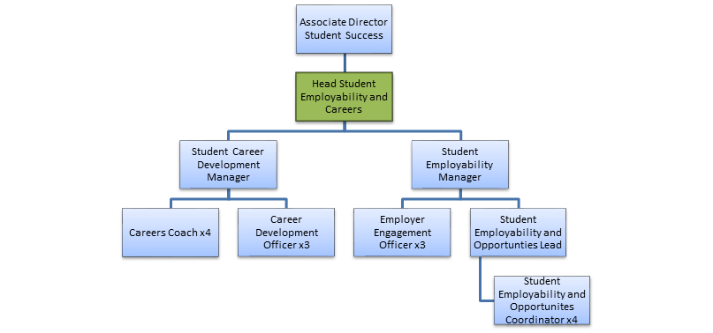

Relationships
Internal
- The post holder will work closely with many of the staff across the Directorate to ensure this joined-up approach, as well as other internal stakeholders, most notably Faculties and Schools/Departments.

External
- The post holder will work with their line manager to maintain relationships with a wide range of external stakeholders. The role will revolve around the maintenance of strong relationships with existing employers and building relationships with new employers and contacts, responding to their demands in an appropriate manner.

