Post Details |  | Last Updated: 10/06/2024
Faculty/Administrative/Service Department | Marketing and Communications
Job Title | Student Communications and Engagement Officer
Job Family | Professional Services |  | Job Level | 4
Responsible to | Internal Communications Manager
Responsible for (Staff)
Job Purpose Statement

You will play a key role in the University’s Internal Communications team which is responsible for delivering engaging staff and student communication to our diverse campus community.
Working closely with the Internal Communications Manager, Student Communications Lead and wider communications team, the Student Communications and Engagement Officer is responsible for telling great stories from across the University of Surrey – with an emphasis on sharing the information our students need to know, inspiring news from our faculties, and information and opportunities of interest to our community. The role holder will collaborate with colleagues and key stakeholders from across the University to deliver great content, campaigns and communications activity across a range of on and offline channels. They will also be responsible for maintaining and updating the student website and digital channels, producing newsletters, social media content and managing internal communications projects.
The role sits within a wider Marketing and Communications department, which prides itself in creating an inclusive, open and supportive environment. We are a central and vital cog in the day-to-day operations of the University and provide important strategic advice and support for teams across the University.
Key Responsibilities
- Develop and implement a multi-channel student communications plan which brings together communication to support, inform and engage students throughout their time at the University – from pre-arrival through to graduation.
- Coordinate and execute student-facing communications campaigns that are aligned with the University’s strategic objectives, including major events, national surveys, onboarding/welcome and students support initiatives.
- Manage the day-to-day student communication channels, ensuring students are kept fully informed and have access to the information they need for a seamless experience at Surrey. This includes (and is not limited to) a student-facing website, dashboard, email campaigns and our digital screen network.
- Brief and project manage internal and external creative designers and agencies to produce digital and print content.
- Proactively use engagement metrics across all channels to monitor and report on communications output, making suggestions for adaptations in response to analytics where relevant.
- Support the Social Media team with planning and creation of social content that is aligned with the social media strategy. This would include development of student (user) generated content using our pool of student content creators.
- Provide advice and support on student communication to key stakeholders across the University, building strong relationships with staff at all levels of the organisation, including Executive Board.
- Support the wider Strategic Communications team with taking a holistic view across the student journey and plan improvement areas in the light of strategic priorities. This could include implementing evaluation and feedback of student communications to ensure operational delivery meets the expectations of all users, and using your own expertise and experience to make recommendations on how to develop and improve our communications.
- Support and deliver reactive/crisis communications where necessary. These situations will always be guided by department and/or University senior management.

N.B. The above list is not exhaustive.

All staff are expected to:
- Positively support equality of opportunity and equity of treatment to colleagues and students in accordance with the University of Surrey Equal Opportunities Policy.
- Work to achieve the aims of our Environmental Policy and promote awareness to colleagues and students. Follow University/departmental policies and working practices in ensuring that no breaches of information security result from their actions. Ensure you are aware of and abide by all relevant University Regulations and Policies relevant to the role.
- Undertake such other duties within the scope of the post as may be requested by your Manager.
- Work supportively and collaboratively with colleagues, operating in a collegiate manner at all times.

Help maintain a safe working environment by:
- Attending training in Health and Safety requirements as necessary, both on appointment and as changes in duties and techniques demand.
- Following local codes of safe working practices and the University of Surrey Health and Safety Policy.

Elements of the Role
Planning and Organising
- You will be responsible for managing the day-to-day communications schedules for the team, including but not limited to web, email and digital screens. These plans must be flexible to adapt to the requirements of a busy, 24/7 university campus, but organised enough to ensure that content is high quality and delivered in a timely manner.
- The post holder will organise and prioritise their own work, to ensure that key deadlines and objectives are met, including successfully managing any conflicting demands, possessing a basic awareness of the options available and being able to make effective and appropriate decisions, referring to their line manager where appropriate.

Problem Solving and Decision Making
- Operate with minimum supervision with regards to the day-to-day planning, organising and performance (to an agreed quality standard and specification) of a wide range of tasks.
- Provide colleagues with professional advice and recommended solutions on all aspects of communications.
- Work with colleagues from across the University to deliver outcome-based solutions to student communications.
- Adapt to shifting priorities and fast-turnaround tasks

Continuous Improvement
- The post holder is encouraged to continually review the impact of their activities and to make suggestions to their line manager and the team for changes and improvements in order to ensure the best service.
- The post holder is expected to edit content from various sources and use their experience and judgement to create the most effective and easily understood communication.
- Keep abreast of the latest trends in marketing, communications and higher education to inform content approaches.
- Strive to deliver sector leading student communications, whilst also looking across the industry to take inspiration from others.
- Nurture the creativity of colleagues and learns from others.
- Use data and analysis to measure effectiveness and inform planning and performance.
- Support the department with the creation of a suite of best practice tools and guides for the wider university, whilst also becoming a “go-to” expert on how to deliver communications to students.
- Willingness to create networks within the University and the Higher Education industry to form opportunities to learn and expand knowledge.

Accountability
- The post holder is expected at all times to exercise their discretion in respect of the confidentiality and sensitivity of the information handled by the Marketing and Communications department.
- You will be accountable for all student communications output, with the full support of the Internal Communications Manager and team, and therefore must ensure that appropriate lines of approval are followed and that colleagues are working collectively to proof all communications output.
- Your line manager will provide development opportunities and coaching, giving constructive feedback, setting individual/collective team targets and mentoring/training staff to support their occupational development.
- Deliver communications with precision, accuracy and creativity, ensuring that good practice in content production is maintained at all times.
Dimensions of the role
- Delivering accurate, well-timed and useful student communications is a core priority for the University and will continue to be so as we progress through the delivery of our Seamless Student Journey strategy.
- You will be expected to be hands on in the role with creating, delivering and analysing communications on a daily basis.
- Great communication and networking skills are essential in order to liaise with multiple stakeholders and teams and build relations.
- Coach others on communications best practice.
- There will be occasions when you will be asked to support other areas of the team, including our Social Media and Staff Communications teams, especially if you are working on projects that are aligned.
- You will be expected to use the suite of IT systems and tools within current publishing and organisation workflows, including Microsoft 365 apps (including Microsoft Teams and Sharepoint), Monday.com, Dot Digital, Wordpress and OnSign TV.

Person Specification
Qualifications and Professional Memberships
Degree, HND, NVQ 4 qualified or equivalent in relevant subject/relevant formal training, plus a number of years' experience in similar or related roles.  Or:  Significant vocational experience, demonstrating development through involvement in a series of progressively more demanding relevant work/roles, and the acquisition of appropriate professional or specialist knowledge |  |  |  |  | E
Technical Competencies (Experience and Knowledge) |  |  |  | Essential/  Desirable | Level  1-3
Experience of using communications delivery platforms and services to plan, create, release and analyse communications, including email service providers, content management systems, social media planning and content creation and reporting tools like Google Analytics. Experience with using personalisation and segmentation where relevant is a plus. |  |  |  | E | 3
Experience of using Microsoft 365 and other productivity tools including Teams, Outlook, Sharepoint and Monday.com (or similar). |  |  |  | E | 3
Experience of delivering multi-channel marketing/communications campaigns, from briefing and planning through to execution and reporting. |  |  |  | E | 2
Excellent writing skills with accuracy and attention to detail, and ability to quality assure copy and material. |  |  |  | E | 2
A working knowledge of communications and content best practice. This could include social media content production, SEO, digital marketing and design, video production or other relevant principles/disciplines. |  |  |  | E | 2
Experience of managing a team/ individuals, including training and development as well as day-to-day guidance and coaching. |  |  |  | D | 2
Experience of developing and implementing communication plans across multiple channels. |  |  |  | E | 3
Good understanding of the key issues in the UK Higher Education industry |  |  |  | D | 2
Experience of coordinating and influencing across a wide range of disparate stakeholders. |  |  |  | E | 2
Ability to use initiative in dealing with issues, as well as a flexible approach to work. |  |  |  | E | 2
Experience of stakeholder engagement across an organisation, including executive/C-suite level. |  |  |  | E | 2
Special Requirements: |  |  |  |  | Essential/  Desirable
The post holder will be involved in supporting University Open Days, Welcome Week and Graduation ceremonies and therefore some occasional evening and weekend working will be expected. Time in lieu is given in line with the University policy. |  |  |  |  | E
Core Competencies |  |  |  |  | Level  1-3
Communication  Adaptability / Flexibility  Customer/Client service and support  Planning and Organising  Continuous Improvement  Problem Solving and Decision-Making Skills  Managing and Developing Performance  Creative and Analytical Thinking  Influencing, Persuasion and Negotiation Skills  Strategic Thinking & Leadership |  |  |  |  | 3  3  3  3  2  2  2  2  1  1
Organisational/Departmental Information & Key Relationships

Background Information
The Marketing and Communications team is led by a director that manages the University-level communication priorities and reports to the Vice-President, Global. The Communications team has three strategic communication priorities in support of the University’s strategy. They are: nurturing a sense of community; promoting our research, innovation, and critical thinking; and being a centre for communication best practice.

This role is a key part of the Internal Communications team, which incorporates the University level functions for staff and student communications and reports into the Internal Communications Manager.

We are operating a blended working approach, meaning that we expect staff to work three days per week in the office, and the rest of the week where they feel they are most productive. We are committed to the University values of inclusion, inspiring our staff and delivering inspiring communications, we are open to innovation and testing ideas, and we work with integrity.

Department Structure Chart
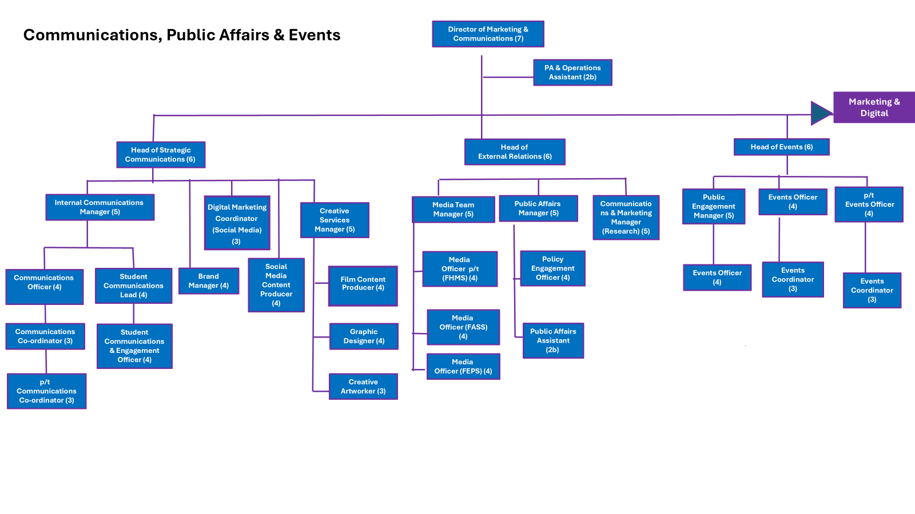

Relationships
Internal
- All colleagues within Communications, Events and Public Affairs
- All colleagues within the wider External Engagement and Marketing departments
- Chief Student Office and student support services
- Executive Board and senior management
- Students’ Union and current students

External
- Creative agencies and freelancers including design, print, video and photography.
- Key partner/external relationships

