Post Details |  | Last Updated: 16 December 2025
Faculty/Administrative/Service Department | Marketing and Communications
Job Title | Communications Co-ordinator
Job Family | Professional Services |  | Job Level | 3
Responsible to | Communications Officer
Responsible for (Staff) | n/a
Job Purpose Statement

Working alongside the Internal Communications Manager and Communications Officer, the Communications Co-ordinator is responsible for telling great stories from across the University of Surrey – with an emphasis on sharing the information our colleagues need to know, inspiring news from our faculties and success stories. This role will contribute to the strategic objective that aims to build a strong Surrey community and helps staff and students feel a sense of pride and belonging to the University.

The Communications Co-ordinator will collaborate with colleagues across the University to deliver great content, campaigns and other communications activity across a range of on and offline channels. They will also be responsible for maintaining and updating the intranet, producing newsletters, undertaking administrative tasks and managing internal communications projects as needed.

Key Responsibilities This document is not designed to be a list of all tasks undertaken but an outline record of the main responsibilities (5 to 8 maximum)
- Write and produce a wide range of online and offline communications for the University’s current staff audience including regular e-newsletters for staff.
- Assist with the management of our intranet, including creating and uploading news, events and supporting/informative content using the content management system (Drupal) and advise on new developments to improve engagement.
- Plan and execute staff engagement campaigns, including producing microsites (using the platform Shorthand), campaign assets and managing photoshoots.
- Work with internal and external creative designers and agencies to project manage the production of digital and print content, including video, imagery and podcast recordings for internal broadcast.
- Collaborate with key internal stakeholders such as colleagues in the Equality, Diversity and Inclusion team, the Human Resources department, Marketing, Campus Services and Estates and the Faculties and Academics to produce high quality, relevant content and campaigns.
- Provide advice and guidance to a range of colleagues on staff communications and associated engagement activities.
- Project coordination as required by the Internal Communications Manager or the Head of Strategic Communications.
- Liaise with internal stakeholders to understand communications objectives and requirements as part of overarching communication objectives.
- Source and use data and insight from across the University to better inform how we communicate with staff, including communications channel analytics, surveys, focus groups and other feedback mechanisms.

N.B. The above list is not exhaustive.
- All staff are expected to:
- Positively support equality of opportunity and equity of treatment to colleagues and students in accordance with the University of Surrey Equal Opportunities Policy.
- Live by the University’s values of innovation, inspiration, inclusion and integrity.
- Work to achieve the aims of our Environmental Policy and promote awareness to colleagues and students.
- Follow University/departmental policies and working practices in ensuring that no breaches of information security result from their actions.
- Ensure they are aware of and abide by all relevant University regulations and policies relevant to the role.
- Undertake such other duties within the scope of the post as may be requested by your Manager.
- Work supportively with colleagues, operating in a collegiate manner at all times.
- Help maintain a safe working environment by:
- Attending training in Health and Safety requirements as necessary, both on appointment and as changes in duties and techniques demand.
- Following local codes of safe working practices and the University of Surrey Health and Safety Policy.
Elements of the Role
This section outlines some of the key elements of the role, which allow this role to be evaluated within the University’s structure. It provides an overview of what is expected from the post holder in the day-to-day operation of the role.

Planning and Organising
- The post holder will organise and prioritise their own work, to ensure that key deadlines and objectives are met, including successfully managing any conflicting demands, possessing a basic awareness of the options available and being able to make effective and appropriate decisions, referring to their line manager where appropriate.
Problem Solving and Decision Making
- Operating with minimum supervision with regards to the day-to-day planning, organising and performance (to an agreed quality standard and specification) of a wide range of tasks.
- Although the role is covered by standard instructions and procedures, the post holder may occasionally experience more unusual queries or issues, where there is no formal guidance. In these cases, the post holder is required to interpret past precedents and apply their judgement to determine an appropriate course of action, or, where resolution is not straightforward, to refer the matter to their line manager for guidance/resolution.
- The post holder may be required to suggest improvements or developments to current working practices in consultation with their manager, to ensure the smooth running of the service they provide.

Continuous Improvement
- The post holder is encouraged to continually review the impact of their activities and to make suggestions to their line manager for changes and improvements to ensure the best service.
- The post holder is expected to edit content from various sources and use their experience and judgement to create the most effective and easily understood communication.

Accountability
- The post holder is always expected to exercise their discretion in respect of the confidentiality and sensitivity of the information handled by the Communications team.
- The post holder will be presented with a variety of administrative and other issues, where the most appropriate course of action will be a matter of choice, influenced by prior exposure or experience.
- In other instances, actions are very well defined procedurally and the post holder is able to reference and apply established policies and procedures, in order to determine a suitable course of action/outcome.
Dimensions of the role
- This post involves no direct line management or budgetary responsibilities.
Person Specification This section describes the total knowledge, experience & competence required by the post holder that is necessary for standard acceptable performance in carrying out this role.
Qualifications and Professional Memberships
HNC, A level, NVQ 3, HND level or equivalent with a number of years' relevant experience.  Or:  Broad vocational experience, acquired through a combination of job-related vocational training and considerable on-the-job experience, demonstrating development through involvement in a series of progressively more demanding relevant work/roles. |  |  |  |  | E
Technical Competencies (Experience and Knowledge) This section contains the level of competency required to carry out the role (please refer to the Competency Framework for clarification where needed and the Job Matching Guidance). |  |  |  | Essential/  Desirable | Level  1-3
Experience of planning and delivering campaigns and communications activity using a variety of online and offline channels |  |  |  | E | 3
Excellent IT skills including good level of user skills in Microsoft Office software, e-mail systems such as DotDigital/Mailchimp and updating web pages using a content management system |  |  |  | E | 3
Experience of writing for on and offline channels as well as publications and reports |  |  |  | E | 3
Accuracy and attention to detail |  |  |  | E | 3
Ability to use initiative in dealing with issues, as well as a flexible approach to work. |  |  |  | E | 2
Ability to work independently on communications plans and routine tasks. |  |  |  | E | 2
Experience of planning and commissioning digital content with external agencies and suppliers (e.g. social media, video, graphics and/or audio) |  |  |  | D | 2
Experience of briefing and working with internal and external creative designers and agencies |  |  |  | D | 2
Experience/understanding of the Higher Education sector |  |  |  | D | 1
Special Requirements: |  |  |  |  | Essential/  Desirable
Ability to work outside of regular office hours as required |  |  |  |  | E
Core Competencies This section contains the level of competency required to carry out this role. (Please refer to the competency framework for clarification where needed). n/a (not applicable) should be placed, where the competency is not a requirement of the grade. |  |  |  |  | Level  1-3
Communication  Adaptability / Flexibility  Customer/Client service and support  Planning and Organising  Continuous Improvement  Problem Solving and Decision Making Skills  Creative and Analytical Thinking  Managing and Developing Performance  Influencing, Persuasion and Negotiation Skills  Strategic Thinking & Leadership |  |  |  |  | 2  2  2  2  2  2  2  n/a  2  n/a
This Job Purpose reflects the core activities of the post. As the Department and the post holder develop, there will inevitably be some changes to the duties for which the post is responsible, and possibly to the emphasis of the post itself. The University expects that the post holder will recognise this and will adopt a flexible approach to work. This could include undertaking relevant training where necessary.

Should significant changes to the Job Purpose become necessary, the post holder will be consulted and the changes reflected in a revised Job Purpose.

Organisational/Departmental Information & Key Relationships

Background Information

The Marketing and Communications team is a key corporate function within the Global Department, pivotal in the delivery of communications activity and expertise to support the University’s overall strategic purpose: To be a leading global university renowned for the outstanding quality and impact of its graduates, research and innovation, together making great contributions to society.
The Communications team incorporates the University level functions for staff and student communications, social media, media relations, public affairs, public engagement, and events management. This post will be part of the internal communications team but will work closely with other members of the wider team.
They will be encouraged to provide support as required by their line manager for University initiatives or events, some of which may fall outside of core working hours (e.g. speaking engagements, University Open Days, which normally take place on a Friday and Saturday twice a year, and Graduation).
We are operating a blended working approach, meaning that we expect staff to work two days per week in the office, and the rest of the week where they feel they are most productive. We are committed to the University values of inclusion, inspiring our staff and delivering inspiring communications, we are open to innovation and testing ideas, and we work with integrity.
We are open to flexible hours within the contracted minimum.

Department Structure Chart
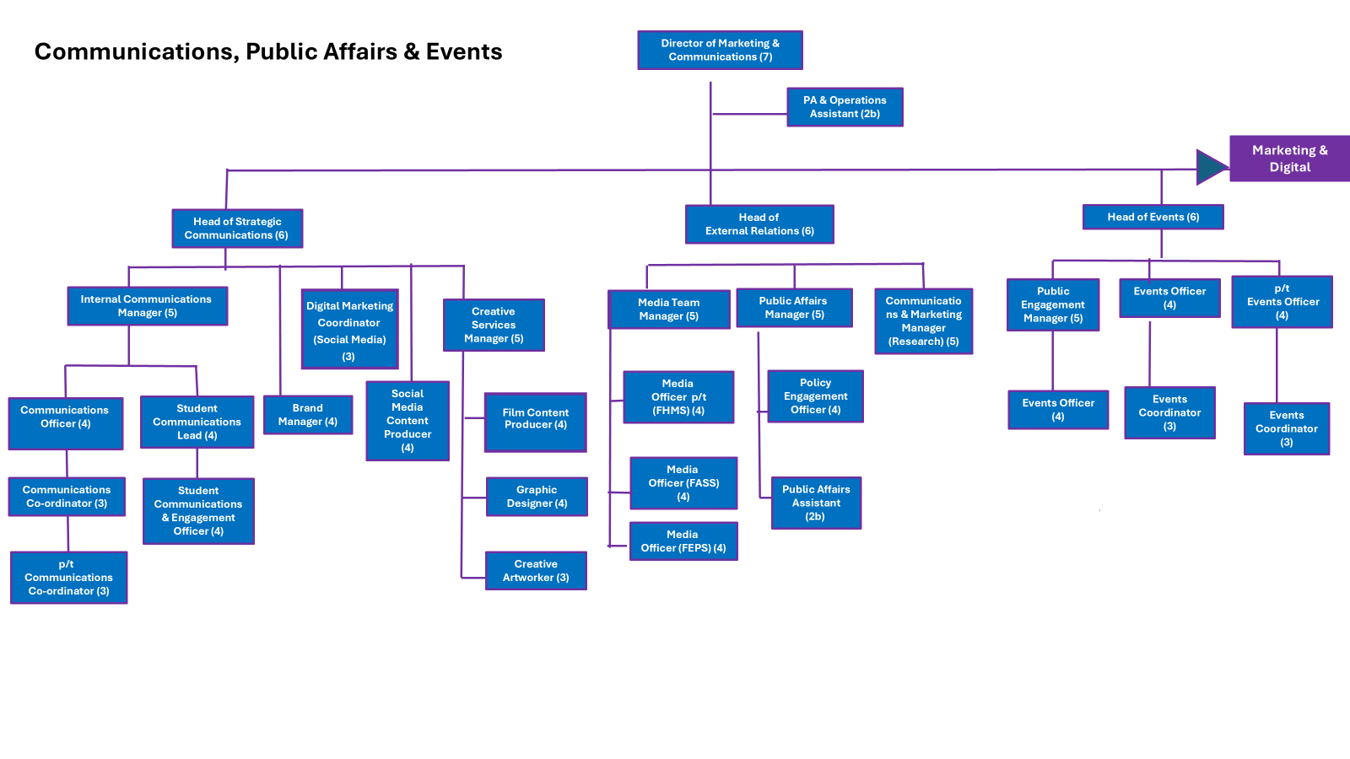

Relationships
Internal
- All colleagues within Marketing and Communications
- All colleagues within the wider University particularly:
- Global
- Human Resources
- Senior Executive Board and Vice Chancellor
- Marketing, Recruitment and Admissions
- IT
- Equality, Diversity and Inclusion
- Campus Services Management and Estates
- Chief Student Office
- Faculties and Academic Community
- Advancement and Alumni

External
- Design agencies and other suppliers

